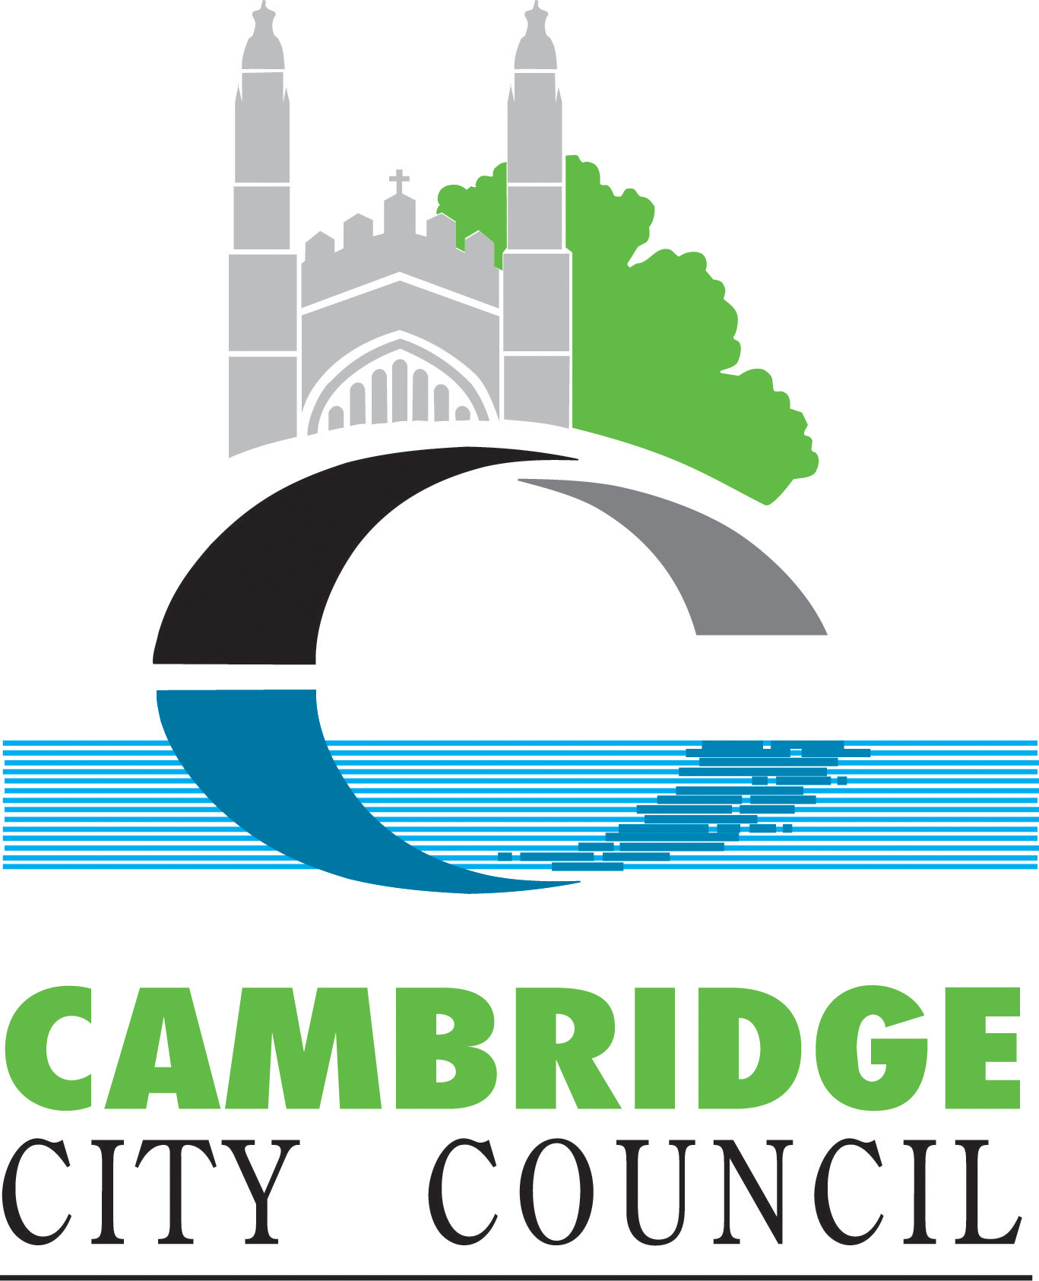

# Council 28 November 2024

Meeting recording: [(1) Cambridge City Council - YouTube](https://www.youtube.com/@camcitco/streams)

## Motion 6g. UN International Day of Solidarity with the Palestinian People

**Background**

* On Thursday 23 May 2024, Cambridge City Council unanimously approved a motion on Palestine and Israel. This followed three separate statements made by the Mayor and personal statements from the three political group leaders.
* In addition, the city council has posted links to the main charities providing support for Gaza here <https://www.cambridge.gov.uk/support-for-gaza>
* As part of this motion, the council wrote to the then government calling upon them to:
  1. Press for an immediate and permanent ceasefire in Gaza, Israel and the rest of Palestine and to make every effort to resume the peace process.
  2. Work to ensure that international humanitarian law is upheld and that civilians are protected in accordance with those laws.
  3. Work to ensure that civilians have access to humanitarian support, including unfettered access of medical supplies, food, fuel and water.
  4. To immediately revoke all licences for arms exports to Israel and suspend arms sales to Israel.

**Active Motion**

* This council notes that currently 73 countries are subject to a non-financial sanction under the Sanctions and Anti-Money Laundering Act 2018. It notes that 38 of these include a direct arms embargo.  Israel is not one of the countries subject to a UK sanction.
* The council notes that since the recent change in government a new country, Belarus, has been included in the list of countries subject to a UK arms embargo on 31 October 2024. Israel has not been added to that list.
* The council notes that the government has changed since it wrote its original letter and resolves to write again to the new secretary of state for Foreign, Commonwealth and Development Affairs, the Rt Hon David Lammy to repeat its requests.
* That the council commemorated United Nations Day on 24 October 2024 by flying the United Nations Flag, as per the Council’s Flag Flying policy which is outlined [here](https://www.cambridge.gov.uk/flags-on-the-guildhall#:~:text=We%20fly%20the%20Union%20Flag,place%20the%20Union%20Flag%20higher.).
* This council also notes that the United Nations International Day of Solidarity with the Palestinian People is commemorated annually on November 29. The council therefore resolves to mark this solemn occasion by flying the United Nations flag at the Guildhall at the first convenient date.

Notes

* The International Day of Solidarity with the Palestinian People is observed by the United Nations on or around 29 November each year, in accordance with General Assembly mandates contained in resolutions [32/40 B](https://documents-dds-ny.un.org/doc/RESOLUTION/GEN/NR0/312/75/IMG/NR031275.pdf?OpenElement) of 2 December 1977, [34/65 D](http://undocs.org/A/RES/34/65) of 12 December 1979, and subsequent resolutions adopted under agenda item “Question of Palestine.”
* On that day in 1947, the General Assembly adopted [resolution 181 (II)](http://undocs.org/a/res/181(II)), which came to be known as the Partition Resolution. That resolution provided for the establishment in Palestine of a “Jewish State” and an “Arab State”. Of the two States to be created under this resolution, only one, Israel, has so far come into being.
* The Palestinian people, who now number over eight million, include those living in the Palestinian territories occupied by Israel since 1967, such as the West Bank, Gaza Strip, and East Jerusalem; within Israel; in neighbouring Arab states; in refugee camps across the region; and in exile in various countries around the world.
* The International Day of Solidarity is an opportunity for the international community to focus its attention on the fact that the question of Palestine remains unresolved and that the Palestinian people have yet to attain their inalienable rights as defined by the General Assembly, namely, the right to self-determination without external interference, the right to national independence and sovereignty, and the right to return to their homes and property, from which they have been displaced.
* In response to the call of the United Nations, various activities are undertaken annually by Governments and civil society in observance of the International Day of Solidarity with the Palestinian People. These activities include the issuance of special messages of solidarity with the Palestinian people.