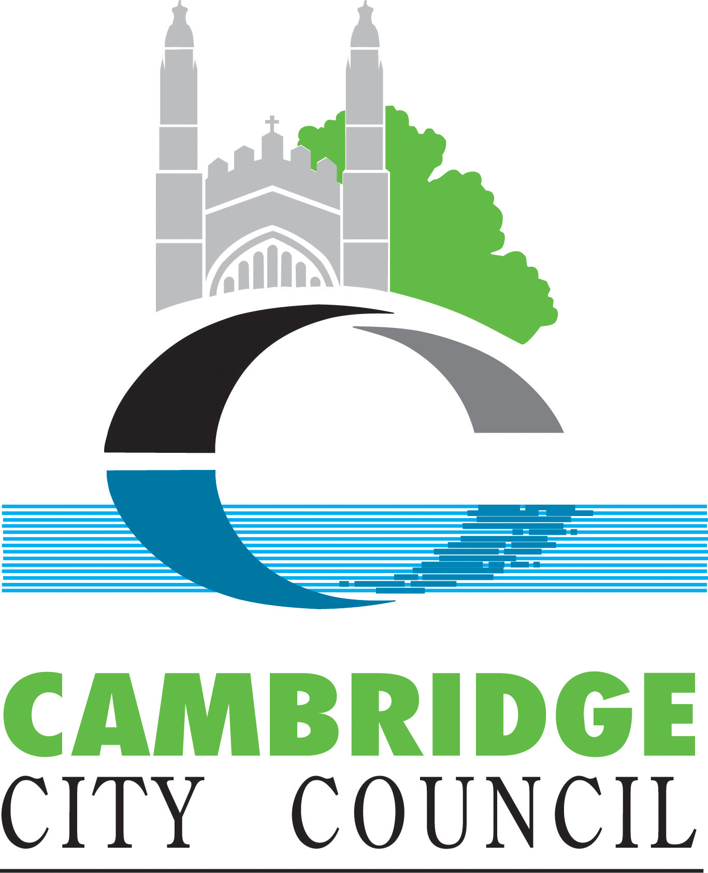

# Council 10 October 2024

Meeting recording: [Council - Thursday, 10th October, 2024 6.00 pm (youtube.com)](https://www.youtube.com/watch?v=Aa_3flF3p18&t=3001s)

## Agenda item 8a. Motion – Cambridge Cancer Research Hospital

Council notes:

* the dire state of public finances left by the last Government.
* the last Government’s unfulfilled, unfunded promise to build forty new hospitals across the country.
* The Labour Government’s welcome announcement to reset the building programme for new hospitals within a clearly defined financial package, based on regional and national priorities
* The importance of the planned Cambridge Cancer Research Hospital to Greater Cambridge’s position as a regional centre of healthcare and the continued development of the vitally important life sciences sector in the region.

Council welcomes the progress made to date on the development of the hospital and notes that the project falls under the recently announced review of the New Hospital Programme to be undertaken by the Department of Health and Social Care since it does not yet have full business case approval for the main build phase.

Council expresses its full confidence in the project and notes that the full business case is expected to be submitted in 2025, that the project has been given full planning permission by this council, and that pre-construction works are planned to begin on site in the coming months, putting the project on track to deliver the hospital by 2029.

Council therefore resolves to:

Ask the Director of Planning to write to the Secretary of State for Health and Social Care reiterating the council’s full support for the Cambridge Cancer Research Hospital and offering to work with Director for Delivery, Performance and Assurance in the DHSC New Hospital Programme sponsor team, who is leading the NHP review, to provide any assistance needed during the review to secure the delivery of this vital facility.